Hello guys..!!!!

This is a sample project on Blockchain just to get you aware of how actually a Blockchain works. Blockchain is a very fast growing & one of the most trending technologies to look out for in coming years. This project is completely done in Python . You can use any IDE , but I personally recommend Spyder which you will get in Anaconda Navigator.

Requirements of this project are:

1.Anaconda Navigator

2.Flask==0.12.2 (type in cmd => pip install Flask==0.12.2 )

3.Postman HTTP client (<https://www.getpostman.com>)

This is a snipet of postman to check whether you’ve downloaded the right thing.

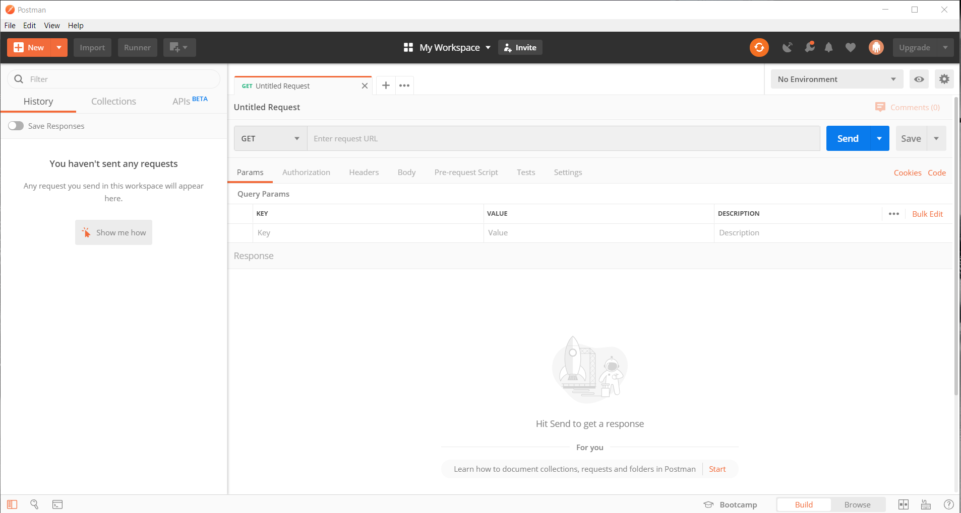

Steps for execution :

1. Download this project and open the Blockchain.py file in Spyder inside the Anaconda Navigator.
2. Run this code in Spyder .
3. After the code executes successfully, minimize the Spyder and open Postman
4. After opening postman you’ll see such kind of requests ,the default will be the GET request which is also the request which we need to run our Blockchain

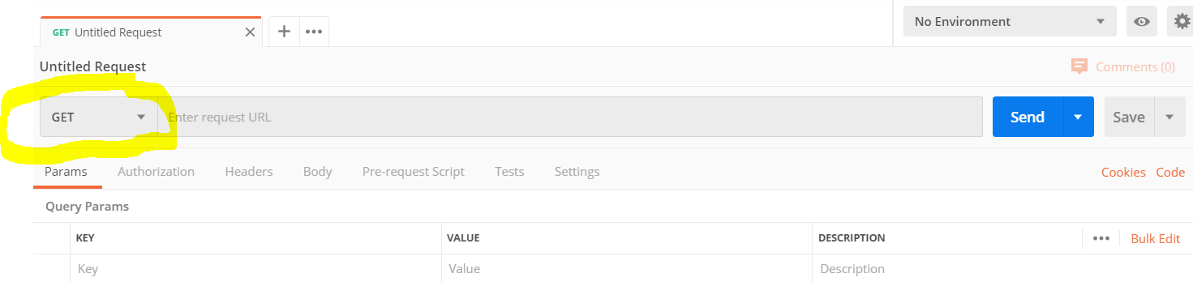

1. Here you’ll see such kind of thing

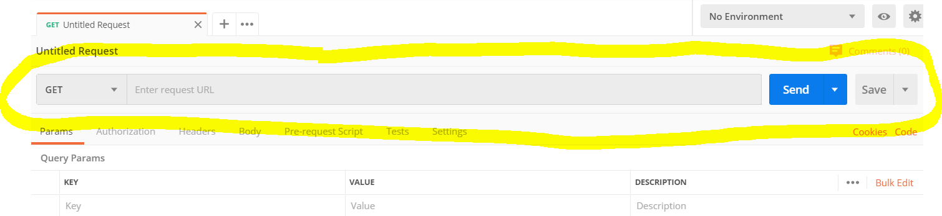

1. In the above stated “Enter Request URL ” type => <http://127.0.0.1:5000/get_chain>

And hit enter

& BOOOOOM here’s your first Blockchain

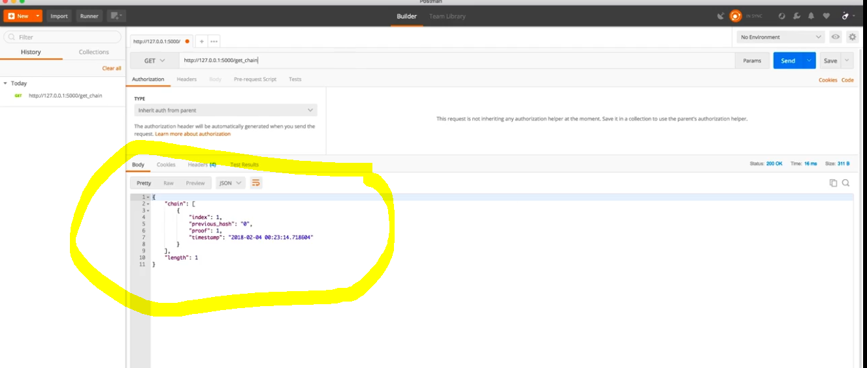

1. Now the above block was our first block that is the genesys block. As this is a genesys block you can see that it has it’s own hash and previous has is “0”.
2. Now again go to request url panel and type mine_block in place of get_chain,,, & BOOOOOOM you just mined a block

This block has an Index 2 & a previos-hash

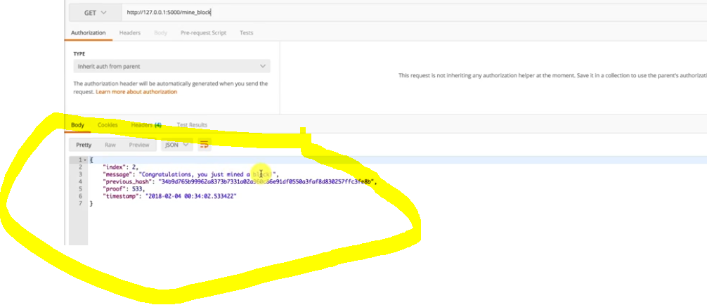

1. Now again changing the rquest to get chain, we can see that the block we just mined is now a part of our Blockchain.

You can continue mining blocks and create your Blockchain.Hope you like my work & in my next project I will show to create your first Cryptocurrency and make transactions.

…!!!